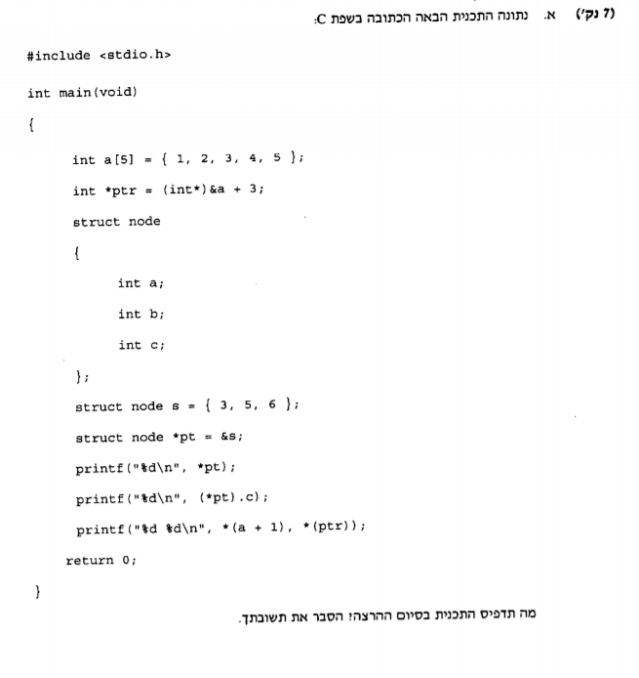

int main(void)

{

int a[5] = { 1,2,3,4,5 };//create array

int *ptr = (int*)&a + 3;//ptr gets the data in loc 3 of array a(4)

struct node

{

int a;

int b;

int c;

};

struct node s = { 3,5,6 };//create node a=3,b=5,c=6

struct node *pt = &s;//create pointer pt with the data of node s equals to a(3)

printf("%d\n", *pt);//prints the data in pt (3)

printf("%d\n", (*pt).c);//print the data of pointer data where equals c and print it (6)

printf("%d\n", *(a + 1), *ptr);//prints the data in location 1 on a array.

//*ptr won't print anything as there is only one % in the print command.

return 0;

}

|  |  |  |  |  |  |  |
| --- | --- | --- | --- | --- | --- | --- |
| a | *ptr | Node a | Node b | Node c | *pt | printf |
| 1,2,3,4,5 |  |  |  |  |  |  |
|  | &a+3 |  |  |  |  |  |
|  |  | 3 | 5 | 6 |  |  |
|  |  |  |  |  | 3,5,6 |  |
|  |  |  |  |  |  | 3 |
|  |  |  |  |  |  | 6 |
|  |  |  |  |  |  | 2 |